**Nimsith Fernandopulle**

**NETD2202 – Lab 3**

**Desk Check**

|  |  |  |
| --- | --- | --- |
| Average Units Shipped by Employees | | |
| Day  Units   |  | | --- | |  | | | |
| Employee 1 | Employee 2 | Employee 3 |
| 100 | 1000 | 200 |
| 200 | 2000 | 400 |
| 300 | 3000 | 600 |
| 400 | 4000 | 800 |
| 500 | 2500 | 1200 |
| 600 | 5000 | 1000 |
| 700 | 4500 | 1400 |
| Average:400 | Average:3142.86 | Average:800 |
| Average Per Day: 1447.62 | | |

|  |  |  |
| --- | --- | --- |
| Average Units Shipped by Employees | | |
| Day  Units   |  | | --- | |  | | | |
| Employee 1 | Employee 2 | Employee 3 |
| 1 | 10 | 100 |
| 1000 | 20 | 200 |
| 3 | 30 | 300 |
| 4 | 40 | 400 |
| 5 | 50 | 500 |
| 6 | 60 | 600 |
| 7 | 70 | 700 |
| Average:146.57 | Average:40.00 | Average:400.00 |
| Average Per Day: 195.67 | | |

**Output if all the values entered by the user is numeric and between 0 and 5000.**

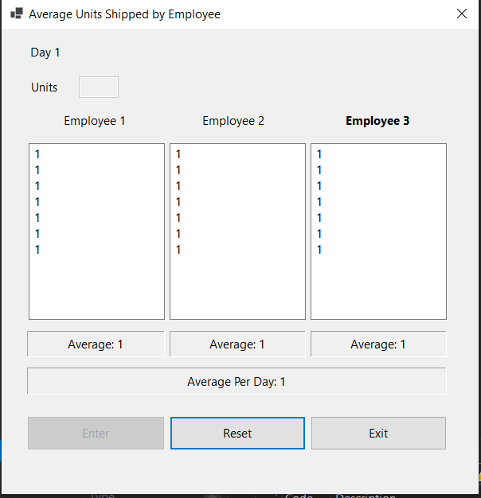

**Validation: If the user enters a value greater than 5000 or less than 0, in this case greater than 5000.**

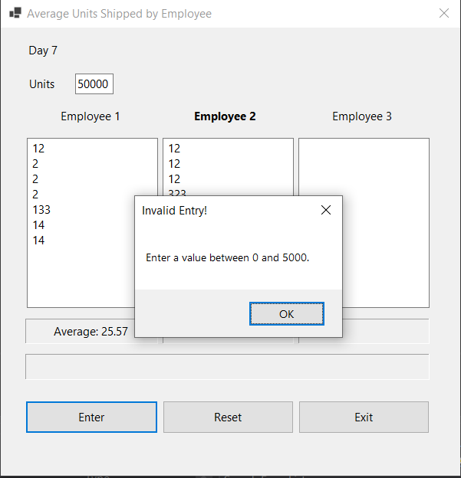

**Validation: If the user enterers a non numeric value this message will pop up.**

